NAME:Rishik JK
REG.NO :192511052

CSA1702-ARTIFICIAL INTELLIGENCE
LAB EXPERIMENT

22. Prolog Program to Check Whether a Particular Bird Can Fly or Not

1. Aim
To write a Prolog program to determine whether a particular bird can fly or not using facts and rules.

2. Algorithm
- Start the program.
- Define facts for birds that can fly.
- Define facts for birds that cannot fly.
- Create a rule to check whether a bird can fly.
- Give the bird name as input.
- Display whether the bird can fly or not.
- Stop.

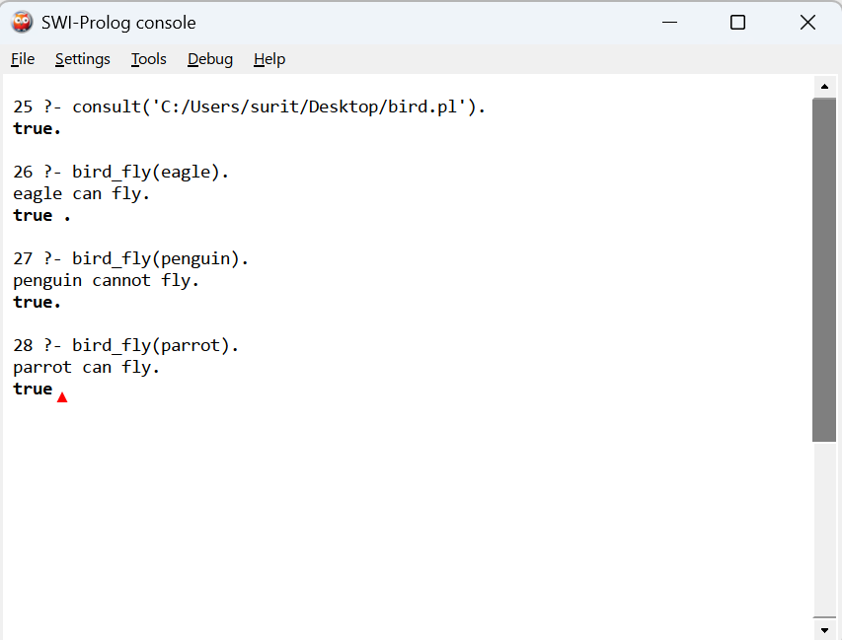

3. Result
Thus, the Prolog program to determine whether a particular bird can fly or not was successfully implemented and executed using facts, rules and queries.

